EUROPEAN COMMISSION
EUROSTAT

Directorate B: Methodology, Corporate statistical and IT services
ORIGINAL EN

Invitation to tender for the supply of statistical services
Analysis of user perception and communication of official statistics in the EU

(ESTAT/B/2017/011)

- Annexes -

LIST OF ANNEXES

Annex 1. Administrative information form
Annex 2. Legal entity form
Annex 3. Financial identification form
Annex 4. Questionnaire for joint bids and/or subcontracting
- Annex 5. Letter of availability of a proposed subcontractor(s)
Annex 6. Power of attorney
Annex 7. Declaration on Honour on exclusion criteria and selection criteria
Annex 8. Compulsory reply form for financial bid
Annex 9. Draft contract
Annex 10. List of documents to be submitted

ANNEX 1. Administrative information form

Identification of the tenderer
(to be completed)
Acting in the capacity of:

Leader of group of economic operators
Member of group of economic operators
Single tenderer

PRIVATE AND PUBLIC ENTITIES
(To be filled in by each member of the group of economic operators in case of a joint tender)
LEGAL NAME OF ORGANISATION :
Are you a Small or Medium Size Enterprise in accordance with Commission Recommendation (2003/361/EC)? | YES / NO
Please indicate the total number of employees
PERSON AUTHORISED TO SIGN THE CONTRACT
Name
First name
Function
SECOND PERSON AUTHORISED TO SIGN THE CONTRACT
Name
First name
Function
Are they authorised to sign independently of each other? | YES / NO
Have you enclosed a copy of the notice of appointment of the persons authorised to represent the tenderer in dealings with third parties? | YES / NO
CONTACT PERSON
Name
First name
Function
Telephone
Fax
Email address
Other contact details

INDIVIDUALS (To be filled in by each member of the group of economic operators in case of a joint tender)
NAME :
First name
Function
Telephone
Fax
Email address
Other contact details

ANNEX 2. Legal entity form
A standard form for individuals, private entities and public entities in each Member State language is available at the following Internet address:
http://ec.europa.eu/budget/contracts_grants/info_contracts/legal_entities/legal_entities_en.cfm

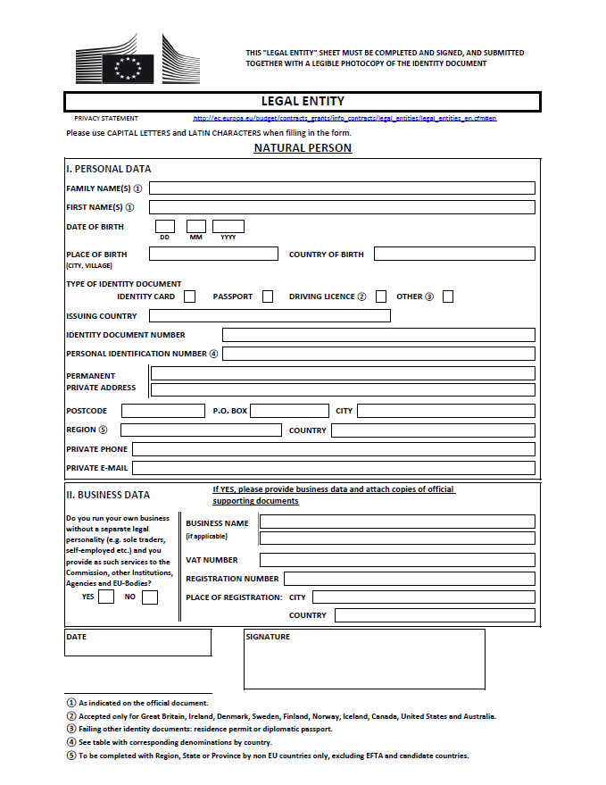
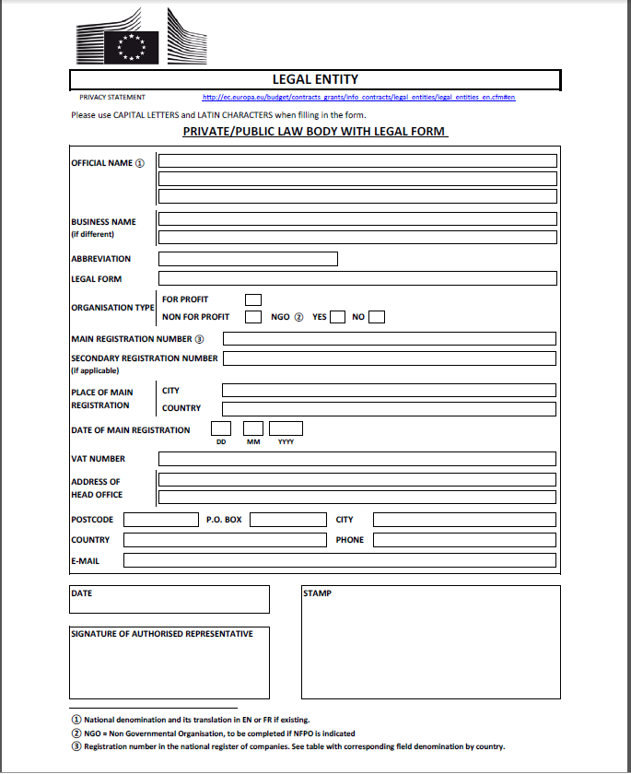
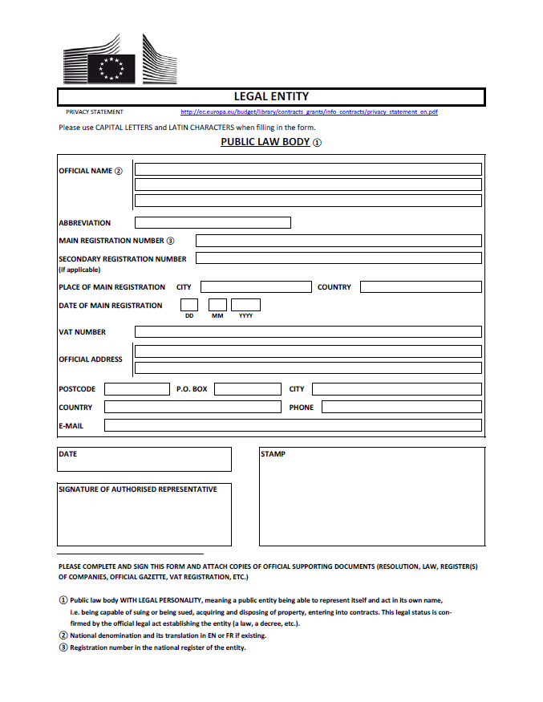

ANNEX 3. Financial identification form

A standard form for individuals, private entities and public entities in each Member State language is available at the following Internet address:
http://ec.europa.eu/budget/contracts_grants/info_contracts/financial_id/financial_id_en.cfm

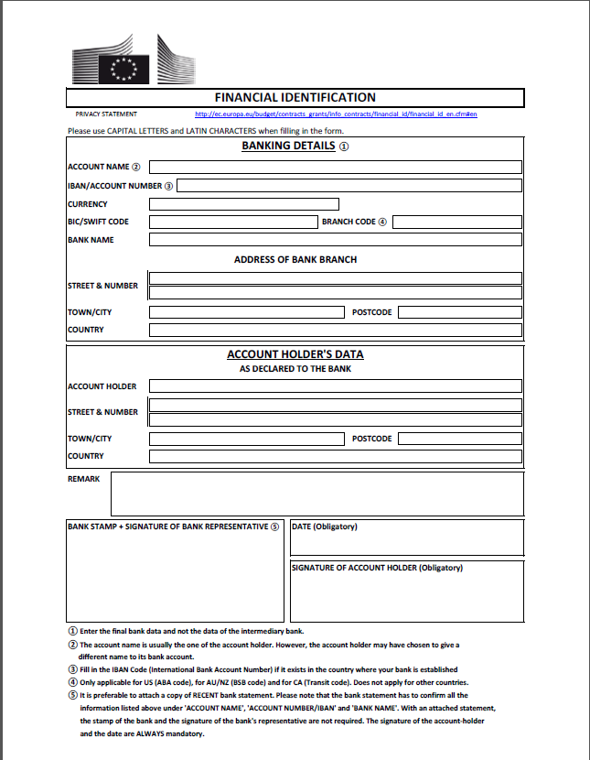
ANNEX 4. Questionnaire for joint offers and/or subcontracting

This questionnaire has to be completed by the tenderer.
In case of joint tender this questionnaire has to be completed by the leader.

Joint offer

1. Does your offer involve more than one tenderer? Yes No
The questions No 2 – 4 shall be answered only if the answer is affirmative.

2. Please fill in the name of the economic operators having power of attorney for the group of tenderers and acting as a co-ordinator:
…….….……………………………….………………………………………..
3. Please fill in the names of the other economic operators taking part in the joint offer:
…….….……………………………….………………………………………..

- If a group of economic operators or similar entity exists, please fill in the name and the legal status of the entity:
…….….……………………………….………………………………………..

Subcontracting

5. Does your offer involve subcontracting? Yes No
If the answer is yes, please complete question number 6, and the next page once for each subcontractor.

6. List of subcontractors:
…….….……………………………….…

Reasons, roles, activities and responsibilities of subcontractors.
Please complete this page once for each subcontractor.

Name of the subcontractor:
…….….……………………………….………………………………………..
Contact person:
…….….……………………………….………………………………………..
Telephone number, e-mail address:
…….….……………………………….………………………………………..
Reasons for subcontracting:
…….….……………………………….………………………………………..
Role, activities and responsibilities of the subcontractor:
…….….……………………………….………………………………………..
The volume or the proportion of the subcontracting:
…….….……………………………….………………………………………..
Do you intend to rely on capacities from the subcontractor in order to fulfill the selection criteria? If yes, specify which selection criterion – financial and economic capacity or technical and professional capacity – and be aware that the tenderer must provide the documents which make it possible to assess the selection criteria to the extent that the subcontractor puts its resources at the disposal of the tenderer.
…….….……………………………….………………………………………..

ANNEX 5. Letter of availability of a proposed subcontractor(s)

Letter of availability of proposed subcontractor

All specific features of a specific project or lot are set out in the detailed description of the project/lot in Part 2 (Technical specifications) of this invitation to tender.

Letter of Intent

I the undersigned, Mr/Ms ……
In my capacity as the subcontractor’s representative/freelancer, hereby declare

Name & address of the subcontractor
Number and title of the tendering procedure
Name of the tenderer

In the event that the contract is awarded to the aforementioned tenderer, the subcontractor undertakes to perform the subcontracted section of the aforementioned contract in accordance with the conditions of the tendering procedure and the tender submitted by the tenderer.

Date Signature
ANNEX 6. Power of attorney
Model 1
(Designating one of the companies of the group as leader and giving a mandate to it)
We the undersigned:

- Signatory 1 (Name, Function, Company, Registered address, VAT Number)
- Signatory 2 (Name, Function, Company, Registered address, VAT Number)
- …..
- Signatory N (Name, Function, Company, Registered address, VAT Number),
Each of them having the legal capacity required to act on behalf of his/her company,

HEREBY AGREE AS FOLLOWS:

(1) The European Commission has awarded Contract following Invitation to Tender No XX/SXX title: xxxxx, lot n° xxxx…. (« the Contract ») to Company 1, Company 2, …, Company N (« the Group Members »), based on the joint offer submitted by them on … ….. for the supply of ….. and/or the provision of services for … (« the Supplies and/or the Services »).
(2) As co-signatories of the Contract, all the Group Members :
(a) Shall be jointly and severally liable towards the European Commission for the performance of the Contract.
(b) Shall comply with the terms and conditions of the Contract and ensure the proper execution of their respective share of the Supplies and/or the Services.
(3) To this effect, the Group Members designate Company X as Group Leader. [N.B.: The Group Leader has to be one of the Group Members]
(4) Payments by the European Commission related to the Supplies or the Services shall be made through the Group Leader’s bank account. [Provide details on bank, address, account number, etc.].
(5) The Group Members grant to the Group Leader all the necessary powers to act on their behalf in connection with the Supplies and/or the Services. This mandate involves in particular the following tasks :
(a) The Group Leader shall sign any contractual documents —including the Framework Contract, Specific Agreements and Amendments thereto— and issue any invoices related to the Supplies or the Services on behalf of the Group Members.
(b) The Group Leader shall act as single point of contact for the European Commission in connection with the Supplies and/or the Services to be provided under the Contract. It shall co-ordinate the provision of the Supplies and/or the Services by the Group Members to the European Commission, and shall see to a proper administration of the Contract.

Any modification to the present agreement / power of attorney shall be subject to the European Commission’s express approval.

This agreement / power of attorney shall expire when all the contractual obligations of the Group Members towards the European Commission in connection with the Supplies and/or the Services to be provided under the Contract have ceased to exist. The parties cannot terminate it before that date without the Commission’s consent.

Signed in …. on ……….. ………

Name  Function  Company | Name  Function  Company
Name  Function  Company | Name  Function  Company

Power of attorney
Model 2
(Creating the Group as separate entity, appointing a Group Manager and giving a mandate to him/her)
We the undersigned:

- Signatory 1 (Name, Function, Company, Registered address, VAT Number)
- Signatory 2 (Name, Function, Company, Registered address, VAT Number)
- …..
- Signatory N (Name, Function, Company, Registered address, VAT Number),
Each of them having the legal capacity required to act on behalf of his/her company,

HEREBY AGREE AS FOLLOWS:

(1) The European Commission has awarded Contract following Invitation to Tender No XX/SXX title: xxxxx, lot n° xxxx…. (« the Contract ») to Company 1, Company 2, …, Company N (« the Group Members »), based on the joint offer submitted by them on … ….. for the supply of ….. and/or the provision of services for … (« the Supplies and/or the Services »).
(2) As co-signatories of the Contract, all the Group Members :
(a) Shall be jointly and severally liable towards the European Commission for the performance of the Contract.
(b) Shall comply with the terms and conditions of the Contract and ensure the proper execution of their respective share of the Supplies and/or the Services.
(3) To this effect, the Group Members have set up under the laws of ……. the Group ….. (« the Group »). The Group has the legal form of a .….. [Provide details on registration of the Group: VAT Number, Trade Register, etc.].
(4) Payments by the European Commission related to the Supplies or the Services shall be made through the Group’s bank account. [Provide details on bank, address, account number, etc.].
(5) The Group Members appoint Mr/Ms ……. as Group Manager.

(6) The Group Members grant to the Group Manager all the necessary powers to act alone on their behalf in connection with the Supplies and/or the Services. This mandate involves in particular the following tasks :
(a) The Group Manager shall sign any contractual documents —including the Framework Contract, Specific Agreements and Amendments thereto— and issue any invoices related to the Supplies or the Services on behalf of the Group Members.
(b) The Group Manager shall act as single point of contact for the European Commission in connection with the Supplies and/or the Services to be provided under the Contract. He/she shall co-ordinate the provision of the Supplies and/or the Services by the Group Members to the European Commission, and shall see to a proper administration of the Contract.
Any modification to the present agreement / power of attorney shall be subject to the European Commission’s express approval.

This agreement / power of attorney shall expire when all the contractual obligations of the Group Members towards the European Commission in connection with the Supplies and/or the Services to be provided under the Contract have ceased to exist. The parties cannot terminate it before that date without the Commission’s consent.

Signed in …. on ……….. ………

Name  Function  Company | Name  Function  Company
Name  Function  Company | Name  Function  Company

ANNEX 7. Declaration on grounds for exclusion (to be provided by each partner in case of joint tender and by each subcontractor)
.
Declaration of honour on
exclusion criteria and selection criteria

INVITATION TO TENDER ESTAT/B/2017/011
Title: Analysis of user perception and communication of official statistics in the EU

The undersigned [insert name of the signatory of this form], representing:

(only for natural persons) himself or herself | (only for legal persons) the following legal person:
ID or passport number: | Full official name:  Official legal form:  Statutory registration number:  Full official address:  VAT registration number:
I - Situation of exclusion concerning the person
(1) declares that the above-mentioned person is in one of the following situation: | YES | NO
- it is bankrupt, subject to insolvency or winding up procedures, its assets are being administered by a liquidator or by a court, it is in an arrangement with creditors, its business activities are suspended or it is in any analogous situation arising from a similar procedure provided for under national legislation or regulations;
- it has been established by a final judgement or a final administrative decision that the person is in breach of its obligations relating to the payment of taxes or social security contributions in accordance with the law of the country in which it is established, with those of the country in which the contracting authority is located or those of the country of the performance of the contract;
- it has been established by a final judgement or a final administrative decision that the person is guilty of grave professional misconduct by having violated applicable laws or regulations or ethical standards of the profession to which the person belongs, or by having engaged in any wrongful conduct which has an impact on its professional credibity where such conduct denotes wrongful intent or gross negligence, including, in particular, any of the following:
(i) fraudulently or negligently misrepresenting information required for the verification of the absence of grounds for exclusion or the fulfilment of selection criteria or in the performance of a contract;
(ii) entering into agreement with other persons with the aim of distorting competition;
(iii) violating intellectual property rights;
(iv) attempting to influence the decision-making process of the contracting authority during the award procedure;
(v) attempting to obtain confidential information that may confer upon it undue advantages in the award procedure;
- it has been established by a final judgement that the person is guilty of any of the following:
(i) fraud, within the meaning of Article 1 of the Convention on the protection of the European Communities' financial interests, drawn up by the Council Act of 26 July 1995;
(ii) corruption, as defined in Article 3 of the Convention on the fight against corruption involving officials of the European Communities or officials of EU Member States, drawn up by the Council Act of 26 May 1997, and in Article 2(1) of Council Framework Decision 2003/568/JHA, as well as corruption as defined in the legal provisions of the country where the contracting authority is located, the country in which the person is established or the country of the performance of the contract;
(iii) participation in a criminal organisation, as defined in Article 2 of Council Framework Decision 2008/841/JHA;
iv) money laundering or terrorist financing, as defined in Article 1 of Directive 2005/60/EC of the European Parliament and of the Council;
(v) terrorist-related offences or offences linked to terrorist activities, as defined in Articles 1 and 3 of Council Framework Decision 2002/475/JHA, respectively, or inciting, aiding, abetting or attempting to commit such offences, as referred to in Article 4 of that Decision;
(vi) child labour or other forms of trafficking in human beings as defined in Article 2 of Directive 2011/36/EU of the European Parliament and of the Council;
- the person has shown significant deficiencies in complying with the main obligations in the performance of a contract financed by the Union’s budget, which has led to its early termination or to the application of liquidated damages or other contractual penalties, or which has been discovered following checks, audits or investigations by an Authorising Officer, OLAF or the Court of Auditors;
- it has been established by a final judgment or final administrative decision that the person has committed an irregularity within the meaning of Article 1(2) of Council Regulation (EC, Euratom) No 2988/95;
- for the situations of grave professional misconduct, fraud, corruption, other criminal offences, significant deficiencies in the performance of the contract or irregularity, the applicant is subject to:
- facts established in the context of audits or investigations carried out by the Court of Auditors, OLAF or internal audit, or any other check, audit or control performed under the responsibility of an authorising officer of an EU institution, of a European office or of an EU agency or body;
- non-final administrative decisions which may include disciplinary measures taken by the competent supervisory body responsible for the verification of the application of standards of professional ethics;
- decisions of the ECB, the EIB, the European Investment Fund or international organisations;
- decisions of the Commission relating to the infringement of the Union's competition rules or of a national competent authority relating to the infringement of Union or national competition law; or
- decisions of exclusion by an authorising officer of an EU institution, of a European office or of an EU agency or body.
II - Situations of exclusion concerning natural persons with power of representation, decision-making or control over the legal person
Not applicable to natural persons, Member States and local authorities
(2) declares that a natural person who is a member of the administrative, management or supervisory body of the above-mentioned legal person, or who haspowers of representation, decision or control with regard to the above-mentioned legal person (this covers the company directors, members of the management or supervisory bodies, and cases where one natural person holds a majority of shares) is in one of the following situations: | YES | NO
Situation (c) above (grave professional misconduct)
Situation (d) above (fraud, corruption or other criminal offence)
Situation (e) above (significant deficiencies in performance of a contract )
Situation (f) above (irregularity)
III - Situations of exclusion concerning natural or legal persons assuming unlimited liability for the debts of the legal person
(3) declares that a natural or legal person that assumes unlimited liability for the debts of the above-mentioned legal person is in one of the following situations: | YES | NO | N/A
Situation (a) above (bankruptcy)
Situation (b) above (breach in payment of taxes or social security contributions)
IV - Grounds for rejection from this procedure
(4) declares whether the above-mentioned person is in one of the following situations or not:
(4) declares that the above-mentioned person: | YES | NO
- has distorted competition by being previously involved in the preparation of procurement documents for this procurement procedure
V - Remedial measures
If the person declares one of the situations of exclusion listed above, it should indicate the measures it has taken to remedy the exclusion situation, thus demonstrating its reliability. They may include e.g. technical, organisational and personnel measures to prevent further occurrence, compensation of damage or payment of fines. The relevant documentary evidence which appropriately illustrates the remedial measures taken should be provided in annex to this declaration. This does not apply for the situations referred in point (d) of this declaration.
VI - Evidence upon request
Upon request and within the time limit set by the contracting authority the person shall provide information on the persons that are members of the administrative, management or supervisory body, as well as the following evidence concerning the person or the natural or legal persons which assume unlimited liability for the debt of the person:
For situations described in (a), (c), (d) or (f), production of a recent extract from the judicial record is required or, failing that, an equivalent document recently issued by a judicial or administrative authority in the country of establishment of the person showing that those requirements are satisfied.
For the situation described in point (a) or (b), production of recent certificates issued by the competent authorities of the State concerned are required. These documents must provide evidence covering all taxes and social security contributions for which the person is liable, including for example, VAT, income tax (natural persons only), company tax (legal persons only) and social security contributions. Where any document described above is not issued in the country concerned, it may be replaced by a sworn statement made before a judicial authority or notary or, failing that, a solemn statement made before an administrative authority or a qualified professional body in its country of establishment.
The person is not required to submit the evidence if it has already been submitted for another procurement procedure. The documents must have been issued no more than one year before the date of their request by the contracting authority and must still be valid at that date.
The signatory declares that the person has already provided the documentary evidence for a previous procedure and confirms that there has been no change in its situation:
Document | Full reference to previous procedure
Insert as many lines as necessary.
VII - Selection criteria
(5) declares that the above-mentioned person complies with the selection criteria applicable to it individually as provided in the tender specifications: | YES | NO | N/A
- It has the legal and regulatory capacity to pursue the professional activity needed for performing the contract as required in section 4.4.1 of the tender specifications;
- It fulfills the applicable economic and financial criteria indicated in section 4.5.1.b of the tender specifications;
- It fulfills the applicable technical and professional criteria indicated in section 4.5.1.b of the tender specifications.

(6) if the above-mentioned person is the sole tenderer or the leader in case of joint tender, declares that: | YES | NO | N/A
- the tenderer, including all members of the group in case of joint tender and including subcontractors if applicable, complies with all the selection criteria for which a consolidated asseessment will be made as provided in the tender specifications.

VIII – Evidence for selection
The signatory declares that the above-mentioned person is able to provide the necessary supporting documents listed in the relevant sections of the tender specifications and which are not available electronically upon request and without delay.
The person is not required to submit the evidence if it has already been submitted for another procurement procedure. The documents must have been issued no more than one year before the date of their request by the contracting authority and must still be valid at that date.
The signatory declares that the person has already provided the documentary evidence for a previous procedure and confirms that there has been no change in its situation:
Document | Full reference to previous procedure
Insert as many lines as necessary.

The above-mentioned person may be subject to rejection from this procedure and to administrative sanctions (exclusion or financial penalty) if any of the declarations or information provided as a condition for participating in this procedure prove to be false

Full name Date Signature

ANNEX 8. Compulsory reply form for financial offer

INVITATION TO TENDER ESTAT/B/2017/011

LOT: "Analysis of user perception and communication of official statistics in the EU"

TENDERER: …………………………………………………………………………

Tasks | Financial proposal in Euro (excl. VAT)
Task 1: Analysis of existing information on user perception of official statistics and the quality of European statistics | …
Task 2: Refinement of the methodology | …
Task 3: Fieldwork | …
Task 4: Analysis and recommendations | …
Task 5: Project management | …
Total amount of offer: | …

All costs associated with the completion of the work, including overheads such as infrastructure, administration, management and travel costs should be included in the financial proposal.

N.B.: Tenderers are required to indicate prices exclusive of VAT.
Prices indicated in the following tables must adhere to these guidelines:
- Prices must be expressed in euros and will not be affected by any changes in the rate of the euro against other currencies.
- Prices may contain only two decimals.
- Prices must be net of VAT.
- All items in the price tables must be completed, failing which the bid will be considered null and void. No clear cells may be left blank. If the price of an item is 0 euros, tenderers must indicate it in that way (no symbols: -, /, etc.).

ANNEX 9. Draft contract

Annex 10 - List of documents to be submitted

Description | Section | Single or Main contractor | Sub-contractor | Coordinator or group leader in joint offer | All partners in joint offer
Administrative information form  Annex 1 | 4.4.1 | ■ |  | ■ | ■
Legal Entity form  Annex 2 | 4.4.1 | ■ | ■ | ■ | ■
Financial identification form  Annex 3 | 4.4.1 | ■ |  | ■
Questionnaire for joint offers and/or subcontracting  Annex 4 | 4.4.1 | ■ | ■ | ■ | ■
Letter of availability of a proposed subcontractor(s)  Annex 5 | 4.4.1 | ■ | ■ | ■ | ■
A letter signed by each member of the group of economic operators giving the authorisation to the lead partner to submit the tender on its behalf. (free format) | 4.4.1 |  |  |  | ■
Power of attorney (to be provided only on request)  Annex 6 | 4.4.1 |  |  | ■ | ■
Declaration on honour (exclusion and selection)  Annex 7 | 4.4.2 | ■ | ■ | ■ | ■
Evidence concerning Grounds for exclusion (to be provided only on request for successful tenderer) | 4.4 | ■ | ■ | ■ | ■
Full set of annual accounts (balance sheet, profit and loss account and notes on the accounts) for the past two years (following the instruction laid down in a paragraph 4.4.3) | 4.4.3 | ■ |  | ■ | ■
Evidence of the educational and professional qualifications (following the instruction laid down in a paragraph 4.4.3) | 4.4.3 | ■ | ■ | ■ | ■
List of the principal services provided in the past three years (following the instruction laid down in a paragraph 4.4.3) | 4.4.3 | ■ | ■ | ■ | ■
Any relevant evidence proving the requirements of the selection criteria (following the instruction laid down in a paragraph 4.4.3) | 4.4.3 | ■ | ■ | ■ | ■
Compulsory reply form for financial offer  Annex 8 | 4.4.5 | ■ |  | ■

